***Project Title:***

“Small Office Network”

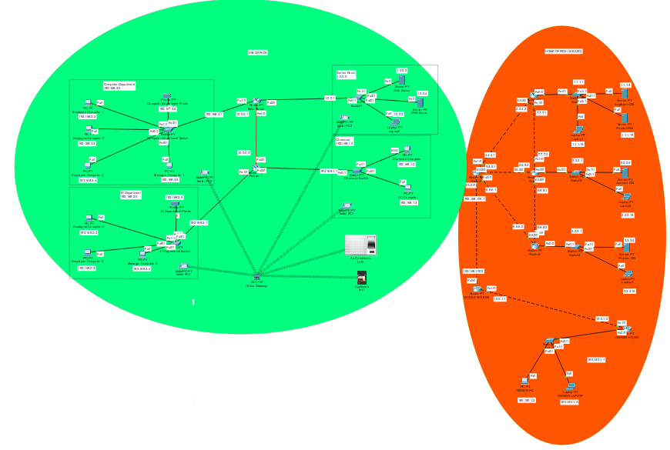

**Introduction**

Welcome to the Small Office Network project with IOT devices + home/office network + company servers, using Cisco Packet Tracer. This project simulates a small office network with distinct networks:

* The Office with IOT devices.
* Server Room
* Chairman Room
* IT Department
* Computer Department.
* Home Office.
* Company Servers.

# **Devices**

* **End Devices**

Assign IP Address to PC, Laptops, Printers, Web and DNS Servers, and connecting tablets with wireless office gateway.

* **Router:**

Assign IP address to the routers.

* 1. Assign static routing in order to send and receive packets from different networks.
  2. Assigning EIGRP Routing method for a more complex router mesh.
  3. Assigning a RIP routing algorithm for a simple home/office network
  4. Combining both RIP + EIGRP for a complete network and for easer communication.
* **Servers**
  1. Webservers for employees, named “the office” where they work.
  2. Servers that contain important information regarding Companies Accounts, employees and projects, they are only accessible by the company’s owner from a separate studio, where these servers are contained.
* **IOT devices**

AC and a coffee machine are the only 2 IOT devices that are used as keeping in view of an office layout. They both are connected to an OFFICE Gateway and are remotely accessible from any room/area of the office.

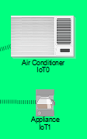

**IOT Devices Access from Tablets**

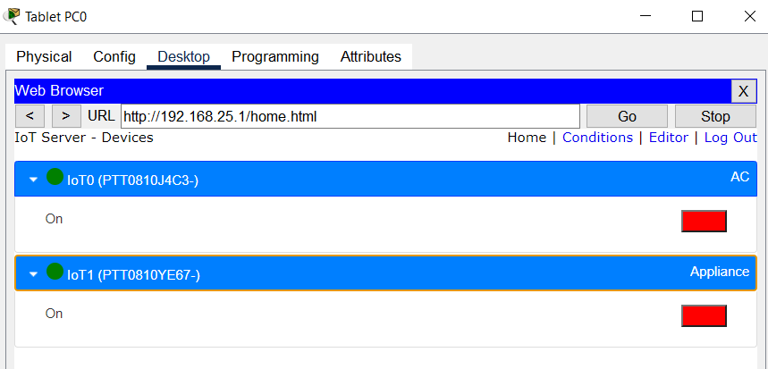

# **Configuration Of Devices**

* **Routers *Routing* mechanism.**
  + 1. **Static Routing:**

Using static routing within the limits of the office as the office has only 2 routers hence, they don’t need a more robust routing mechanism and a static one works best. This router is connected to 4 parts of the office including Servers which the Employees and Managers use to access their work.

**Routers with Static Routing**

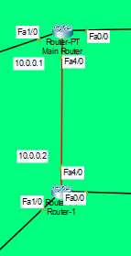

**Static Router 1**

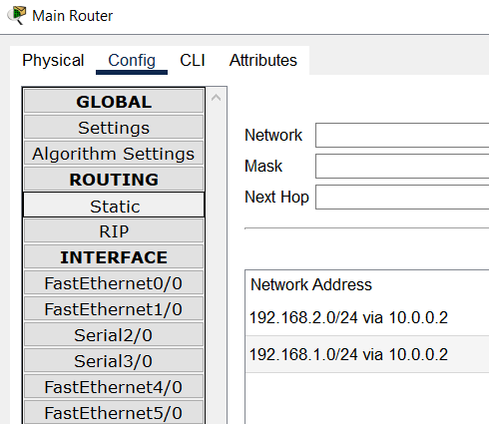

**Static Router 2**

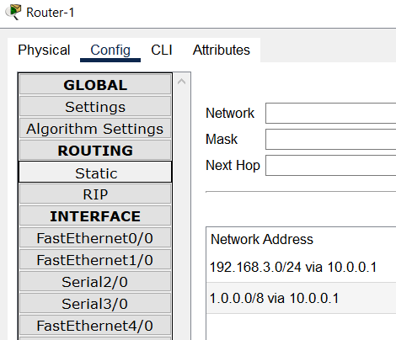

* + 1. **EIGRP + RIP routing**

The Owner of the company is responsible for what ever is happening in the company; hence he can view his employees, accounts and projects info from his own personal devices, or anywhere within his studio’s devices.

His studio has the databases for all the accounts, employees and project related information stored.

Here the 1st part of the studio near/the personal space of the Owner uses ***RIP*** routing mechanism over his routers and the other part uses ***EIGRP***, where all the servers are located, and at the end they all are connected to a central (MIDDLE Router) which ***redistributes both RIP and EIGRP*** routers request to one another.

**Middle Router**

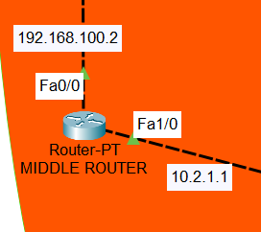

**Owners Personal Router with RIP**

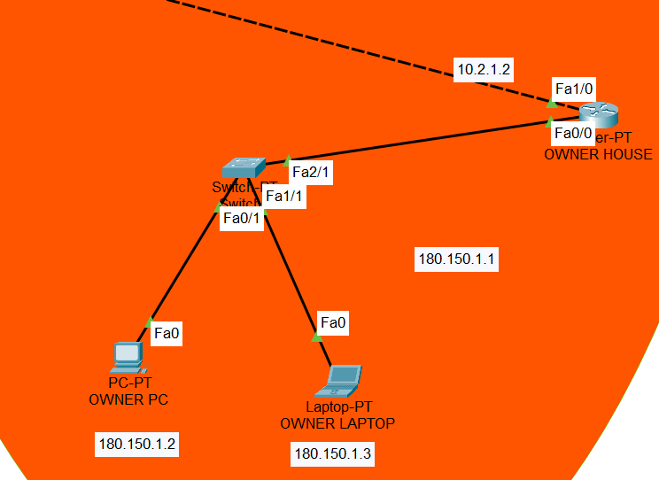

**Routers with Databases and EIGRP**

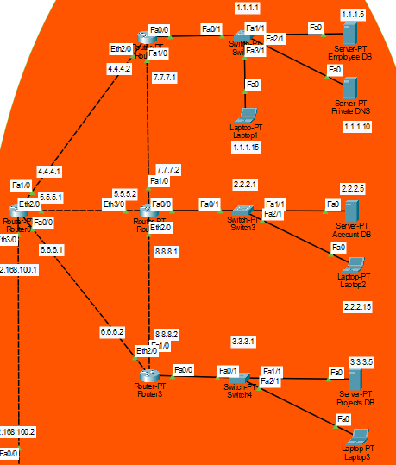

# **Redistribution RIP -> EIGRP**

***(Middle Router)***

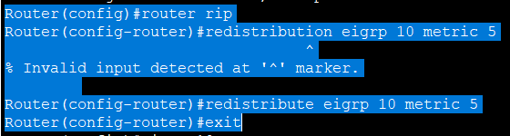

**Redistribution EIGRP -> RIP**

***(Middle Router)***

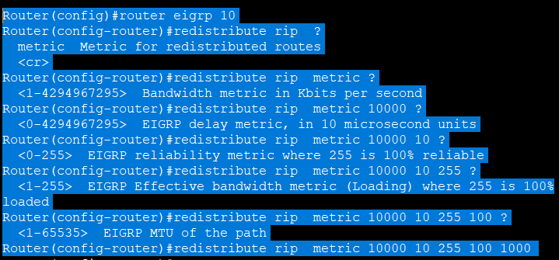

# **Features**

* **The Office (Website):**

Website only used by employees & managers within the office, named as “THE OFFICE”.

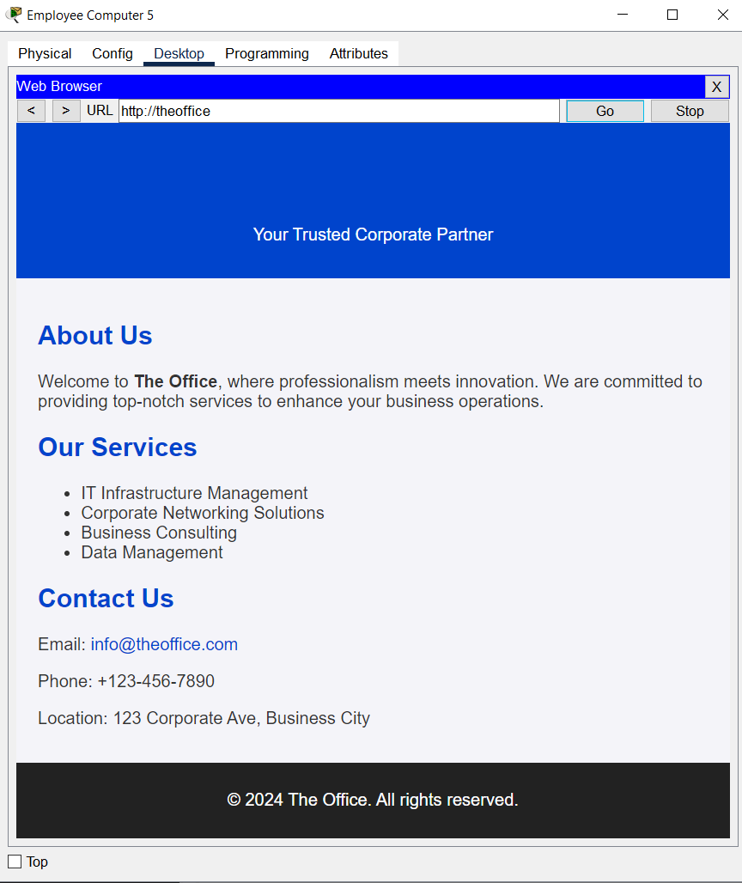

**The Office Servers and DNS**

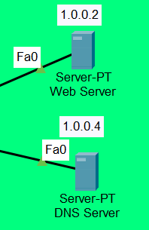

**DNS Services**  
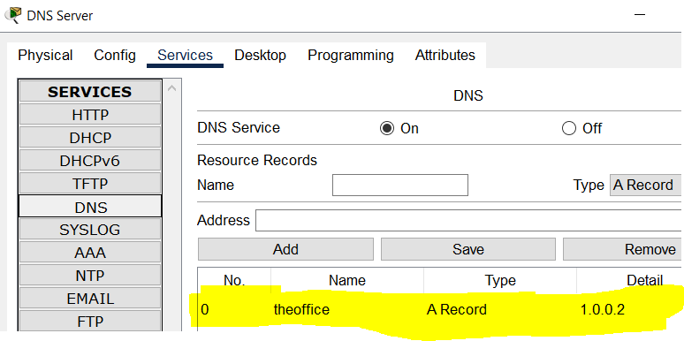

* **Accounts (Website):**

The financial position of the company can only be viewed by its owner by its own personal or studio device.

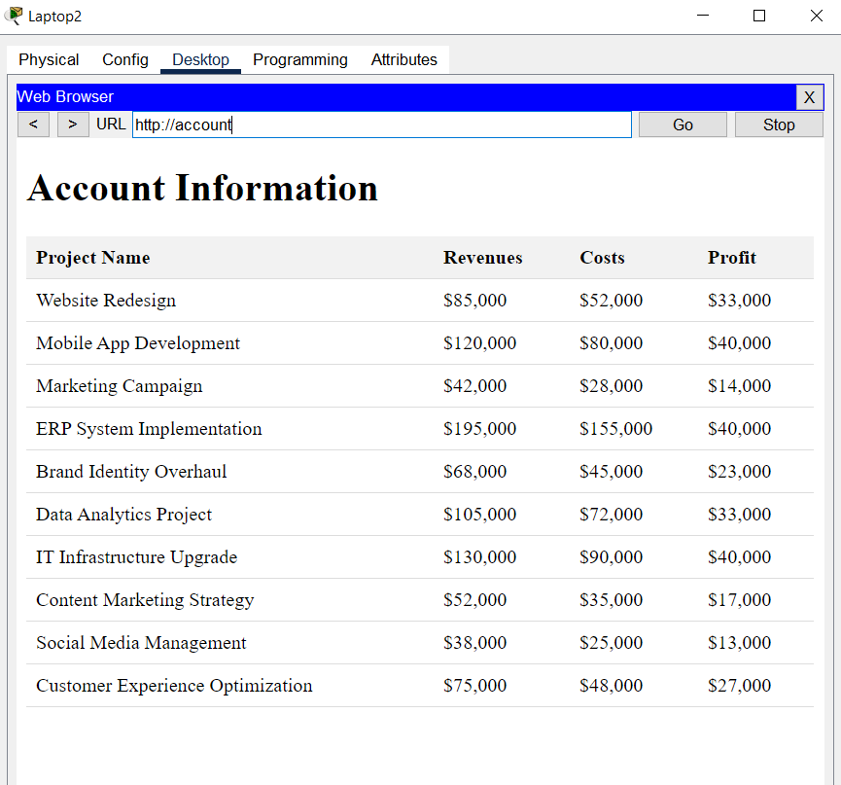

* **Employee (Website):**

Similarly, as accounts, the owner has the privileges to view the employee info from his personal or studio device.

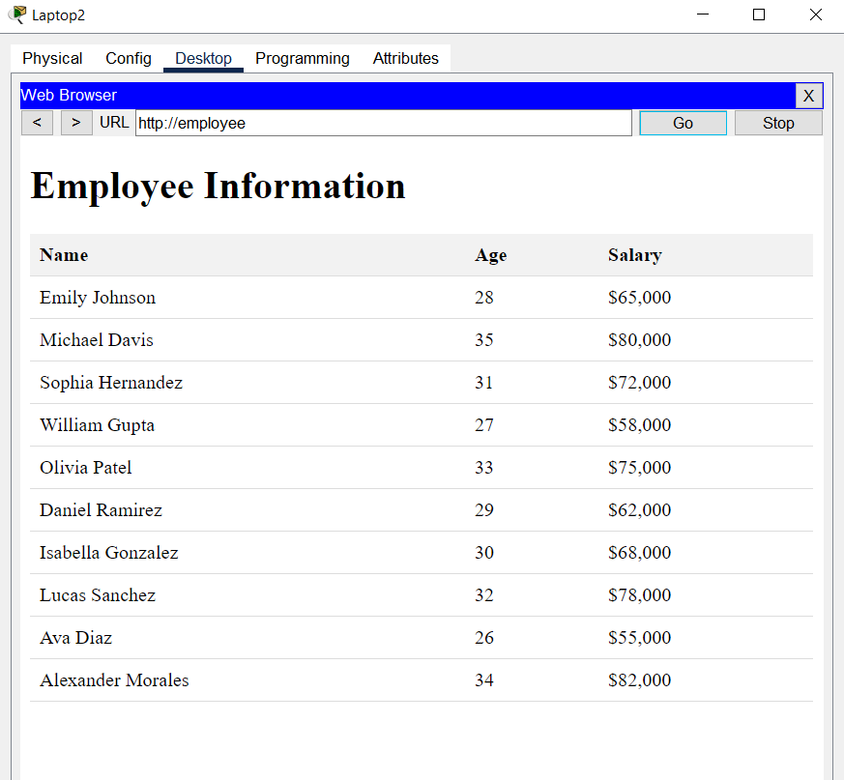

* **Projects (Website):**

The Owner can view all the companies’ projects from the studio devices.

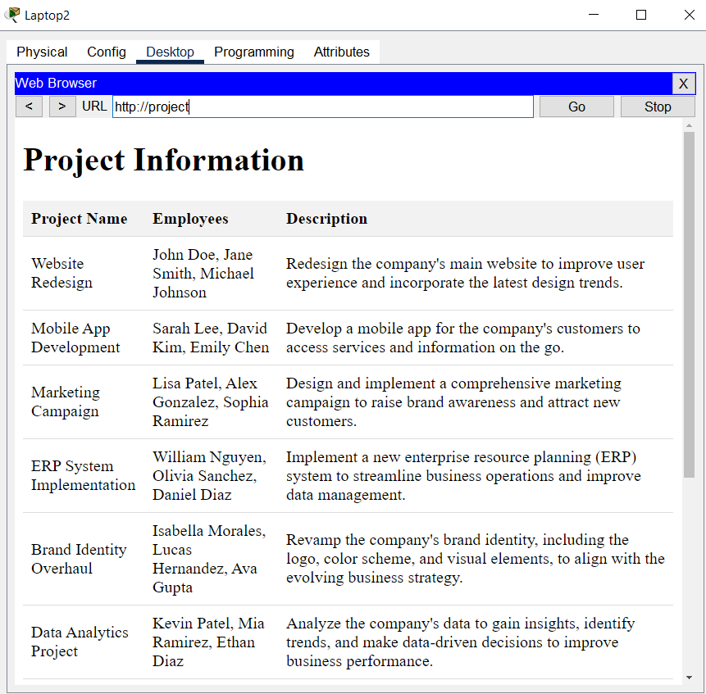

**Employee + Account + Project Server and DNS**

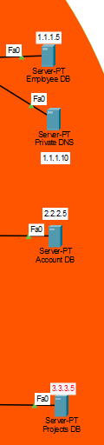

**DNS services for all Database Servers**

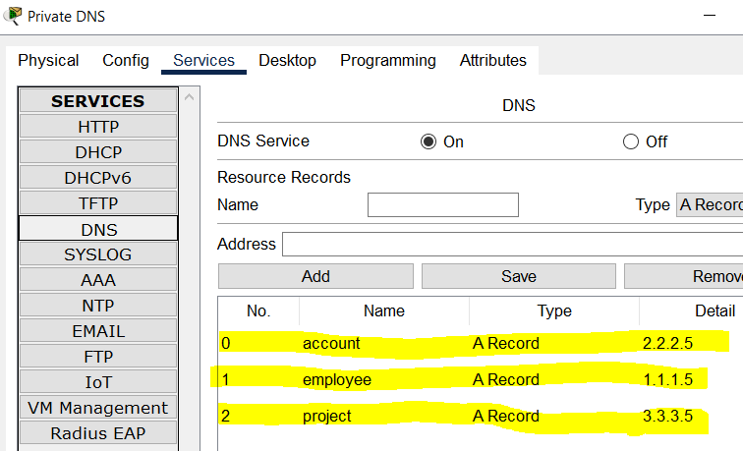

**Conclusion:**

An office network with devices connected to facilitate employees of the company and their managers. They can use their company’s official website to work, drink coffee when ever they need and can change the temperatures of the office from the tablets present in all the rooms of the office.

The owner of the company can keep and eye on his employees, accounts and projects on which the employees are working from a separate network from the comfort of his studio.

**------------------------------------**